**A**

**Synopsis on**

**AI-CAL: An Intelligent Calculator for Advanced Mathematical Solutions**

*By*

|  |  |  |
| --- | --- | --- |
| **Sr. No** | **Name** | **Roll No.** |
| **1** | **Soham Dharne** | **36** |
| **2** | **Pallavi Mohite** | **37** |
| **3** | **Pratik Patil** | **38** |
| **4** | **Ritesh Patil** | **39** |
| **5** | **Rutuja Vhanmane** | **40** |

under the guidance of

**S.M.Momin**



DEPARTMENT OF CSE

(ARTIFICIAL INTELLIGENCE & MACHINE LEARNING)

### BHARATI VIDYAPEETH’S

### COLLEGE OF ENGINEERING, KOLHAPUR

**YEAR: 2024-25**

# **I. Introduction**

"In today's fast-paced world of technology, the need for advanced mathematical tools has grown significantly. Traditional calculators, while useful for simple tasks, often fall short when faced with more complex challenges such as recognizing handwritten equations or interpreting inputs from images and gestures. This limitation creates a gap in functionality, particularly for users requiring more dynamic and intuitive solutions."

1. Increasing need for tools to perform advanced mathematical calculations beyond basic calculators.

2.Traditional calculators are inadequate for complex problems, handwritten inputs, or image/gesture recognition.

3. AI-CAL integrates AI technology into a user-friendly calculator to solve equations from images, handwritten notes, and gestures.

4. AI-CAL uses machine learning models for accurate and instant results, enhancing productivity and accessibility.

5. Useful for students, researchers, and professionals needing quick and reliable complex calculations.

**II. AN OVERVIEW OF EXISTING SYSTEM AND CHALLENGES IDENTIFIED**

**a) Existing System**

The integration of artificial intelligence in mathematical problem-solving has been a growing field of research. Various studies have explored the use of AI in enhancing computational tools, focusing on image recognition, natural language processing, and gesture-based interfaces to create more intuitive and accessible mathematical software.

1. **Existing Tools and Techniques:**

Traditional calculators and software tools such as MATLAB, Wolfram Alpha, and specialized calculators have long been the mainstays for performing mathematical computations. However, these tools often require users to input data in specific formats, limiting their accessibility and flexibility. Recent advancements in AI have led to the development of systems capable of interpreting handwritten equations and solving them in real time, such as Microsoft’s Math Solver and Apple’s Scribble feature.

Research has also focused on the application of deep learning models for handwritten digit recognition, a fundamental step in developing intelligent calculators that can understand and process handwritten mathematical expressions. Techniques such as convolutional neural networks (CNNs) have proven highly effective in this domain, with accuracy rates exceeding 99% in some studies.

In addition, gesture recognition systems, employing technologies like OpenCV, have gained attention for their potential to create hands-free interfaces for mathematical tools. These systems utilize machine learning algorithms to interpret user gestures, enabling a more natural interaction with computational devices

**b) CHALLENGES IDENTIFIED**

Despite these advancements, several challenges remain in the existing systems:

**Limited Input Flexibility**: Many current tools require users to enter equations in a specific format, which can be cumbersome and time-consuming. This limitation is particularly evident in systems that struggle to accurately interpret handwritten inputs or complex mathematical symbols.

**Accuracy and Interpretation:** While AI-based systems have made strides in recognizing handwritten equations and mathematical expressions, accuracy can still be an issue, especially with complex or non-standard notations. Misinterpretation of inputs can lead to incorrect solutions, reducing the reliability of these tools.

**Usability and Accessibility:** Traditional calculators and even some advanced software tools are not always user-friendly, particularly for those with disabilities or those who prefer more intuitive interfaces. The lack of gesture-based or voice-controlled features in most tools limits their accessibility for a broader audience.

**Real-time Processing:** Real-time processing of complex mathematical problems, especially from image inputs or gesture-based systems, remains a technical challenge. Latency and computational overhead can hinder the user experience, particularly on mobile or low-power devices.

# 

# **III. PROBLEM STATEMENT**

**AI-CAL: An Intelligent Calculator for Advanced Mathematical Solutions**

In today's rapidly advancing technological world, the need for efficient and intelligent tools for mathematical calculations and statistical analysis is paramount. Traditional calculators, while useful, lack the capabilities to interpret complex inputs such as handwritten equations, images of mathematical problems, and gesture-based interactions. This limitation creates a gap in accessibility and usability for users who require more dynamic and intuitive interfaces for problem-solving.The project "AI-CAL" addresses this gap by developing an AI-based calculator that integrates advanced AI models to enhance the user experience.

**Why this Topic was Selected:**

The selection of this topic, **AI-CAL: An Intelligent Calculator for Advanced Mathematical Solutions**, is driven by several key factors:

**1.Bridging the Gap in Existing Solutions:**

Current calculators and mathematical tools are often restricted to simple inputs, such as typed equations or basic arithmetic operations. These tools are insufficient when dealing with complex mathematical problems that are presented in non-standard formats like images or handwritten notes. AI-CAL aims to bridge this gap by integrating advanced AI technologies to interpret and solve mathematical problems from diverse inputs.

**2.Leveraging Advanced AI Technologies:**

With the advancements in artificial intelligence, machine learning, and computer vision, there is a significant opportunity to create a tool that goes beyond traditional calculators. AI-CAL will leverage these cutting-edge technologies to offer a more versatile and powerful solution that can adapt to various user needs and input methods.

**3.Enhancing Accessibility and User Experience:**

Many existing mathematical tools are not designed with accessibility in mind, often requiring specific input formats that may not be convenient for all users. AI-CAL addresses this issue by incorporating handwriting and gesture recognition, making it more accessible and user-friendly, particularly for those who may have difficulties with traditional input methods.

**4.Academic and Practical Relevance:**

The topic is highly relevant both academically and practically. In an academic setting, AI-CAL can serve as a valuable tool for students and educators, providing a more interactive and effective way to learn and solve mathematical problems. Practically, it has the potential to be used by professionals in various fields, such as engineering, finance, and research, where complex calculations are a routine part of the work.

**5.Contribution to the Field of AI and Mathematics:**

By combining AI with mathematical problem-solving, this project contributes to the ongoing development and application of artificial intelligence in innovative ways.

**IV. OUTLINE OF THE PROPOSED WORK**

**4.1 Objectives**

The primary objectives of the AI-CAL project are:

To develop an AI-powered calculator capable of solving advanced mathematical problems through various input methods, including images, handwritten equations, and gestures.

To enhance accessibility and usability by integrating intuitive interfaces, such as gesture recognition and real-time handwriting interpretation, allowing users to interact with the calculator naturally and efficiently.

To provide accurate and instantaneous solutions by employing advanced machine learning models and deep learning techniques, ensuring the system can handle complex mathematical tasks with high precision.

**4.2 System Architecture Diagram:**

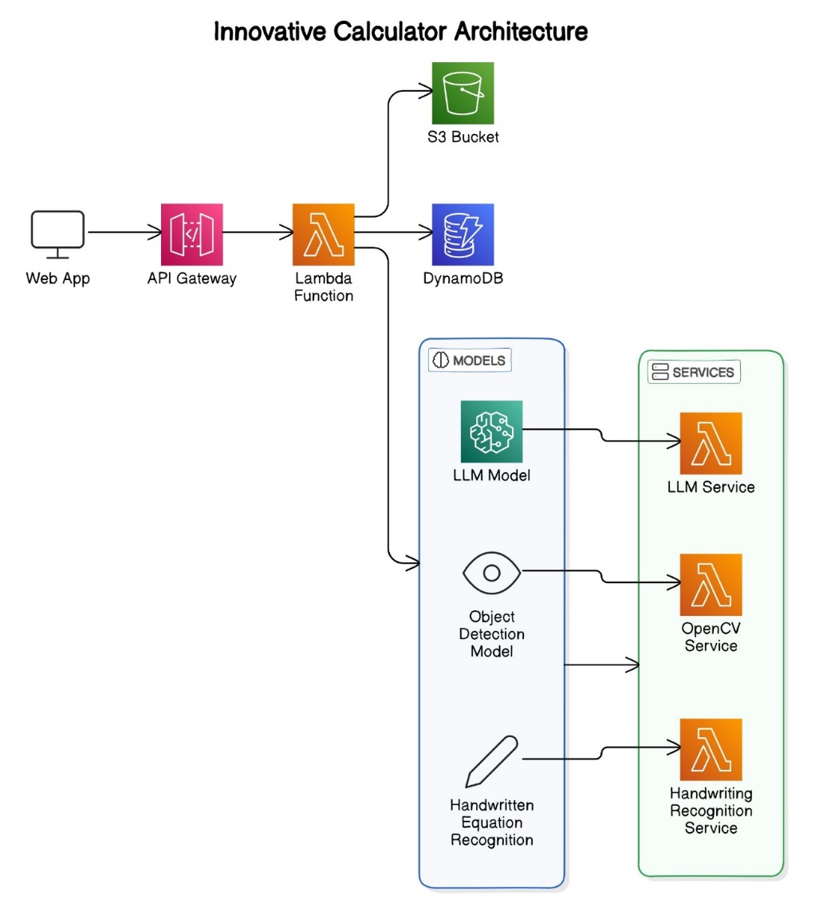

**Input Layer:**

Image Recognition Module: Handles image inputs of mathematical problems and extracts relevant information.

Handwritten Equation Recognition Module: Interprets handwritten mathematical equations.

Gesture Recognition Module: Processes gestures to perform calculations.

Processing Layer:

LLM-based Model: Analyzes inputs from the image recognition module and generates solutions.

Handwriting Analysis Engine: Utilizes deep learning techniques for real-time interpretation of handwritten inputs.

OpenCV-based Object Detection Model: Detects and interprets user gestures to execute corresponding actions.

**Output Layer:**

Result Display: Provides solutions to the user in a clear and understandable format.

Feedback Mechanism: Allows users to correct or refine inputs for improved accuracy.

User Interface:

A unified interface that supports image uploads, handwritten inputs, and gesture-based interactions.

**4.3 List of Modules**

The AI-CAL system is divided into the following key modules:

**Image Recognition and Problem Solving Module:**

Description: This module leverages a Large Language Model (LLM) to detect and solve mathematical problems from images or PDFs. The model processes the visual input, recognizes the mathematical equations, and provides immediate solutions.

**Handwritten Equation Recognition Module:**

Description: Similar to Apple's Notes calculator, this module allows users to draw mathematical equations using a stylus or their finger. The system interprets these handwritten equations in real time and delivers accurate solutions.

**Gesture Recognition and Calculation Module:**

Description: Powered by OpenCV, this module interprets user gestures to perform calculations. It offers a hands-free, intuitive approach to problem-solving, particularly useful in scenarios where traditional input methods are less convenient.

**Solution Output and Feedback Module:**

Description: This module is responsible for displaying the final results to the user. It also includes a feedback mechanism where users can refine their inputs, ensuring the system’s accuracy and adaptability.

**User Interface (UI) Module:**

Description: This module provides a cohesive and user-friendly interface that integrates all the functionalities

**V. REQUIREMENT ANALYSIS**

**a. H/W REQUIREMENTS:**

The hardware requirements for AI-CAL are determined by the need to process large datasets, run complex AI models, and provide real-time solutions efficiently. The following are the primary hardware components required:

High-Performance Computing System:

Processor: Intel Core i7 or AMD Ryzen 7 (or higher) to handle the computational demands of AI models.

RAM: 16 GB or more to support multitasking and large-scale data processing.

GPU: NVIDIA GTX 1080 Ti or higher for accelerated deep learning model training and inference, particularly for image and gesture recognition.

Storage: SSD with at least 512 GB to ensure quick data access and sufficient storage for large datasets and models.

Peripheral Devices:

Graphics Tablet or Stylus: Required for capturing handwritten inputs accurately.

Webcam or High-Resolution Camera: For capturing images or gestures, essential for the image recognition and gesture detection modules.

Touchscreen Monitor (optional): Facilitates easier interaction with the calculator, especially for testing the handwriting and gesture recognition modules.

Additional Hardware:

Server (optional): If cloud-based processing is required, a server with high computational power and sufficient storage may be necessary.

Network Setup: Stable and high-speed internet connection for accessing cloud resources, if applicable.

b. S/W REQUIREMENTS:

The software stack for AI-CAL includes operating systems, development tools, machine learning libraries, and additional software necessary for building and testing the system. The following are the key software components:

Operating System:

Windows 10/11, macOS, or Linux (Ubuntu): A stable operating system that supports the development environment and required software.

Development Environment:

IDE: PyCharm, Visual Studio Code, or Jupyter Notebook for coding and testing Python-based AI models.

Version Control: Git for managing code versions and collaborating with team members.

Machine Learning Libraries and Frameworks:

TensorFlow/PyTorch: For developing and training deep learning models, particularly for image and gesture recognition.

OpenCV: Used for image processing and gesture recognition tasks.

NumPy, Pandas: Essential for data manipulation and numerical computations.

Scikit-learn: For integrating traditional machine learning models if needed.

Additional Software:

LaTeX/Markdown: For documenting the project and preparing reports.

Matplotlib/Seaborn: For visualizing data and results during the development and testing phases.

Docker (optional): For containerizing the application and ensuring consistent environments across different systems.

Cloud Services (optional): AWS, Google Cloud, or Azure, if remote processing or storage is necessary.

Testing and Debugging Tools:

Unit Testing Frameworks: PyTest or Unittest for automated testing of code modules.

Debuggers: Integrated with IDEs for real-time debugging.

5.3 Data Requirements

AI-CAL requires various datasets for training and testing its AI models:

Image Dataset: A large collection of images containing mathematical equations, necessary for training the image recognition module.

Handwritten Equations Dataset: Handwritten samples of different mathematical equations for training and testing the handwriting recognition module.

Gesture Dataset: A dataset containing various hand gestures to train the gesture recognition model.

**VI. METHODOLOGY**

The development of AI-CAL involves the integration of various advanced technologies and theoretical concepts to achieve a seamless and efficient mathematical problem-solving tool. This section outlines the key methodologies and concepts that will be utilized in the project.

**6.1 Artificial Intelligence (AI) and Machine Learning (ML)**

**1. AI-Driven Problem Solving:**

The core functionality of AI-CAL is driven by AI algorithms capable of interpreting and solving complex mathematical problems. AI techniques, such as natural language processing (NLP) and computer vision, are employed to analyze different input types (e.g., images, handwriting, gestures) and generate accurate solutions.

**2. Machine Learning for Recognition Tasks:**

Machine learning models, particularly those based on deep learning, will be trained to recognize handwritten equations, mathematical symbols, and gestures. Convolutional Neural Networks (CNNs) are particularly useful for image and gesture recognition tasks, as they are capable of learning patterns and features directly from input data.

Supervised learning techniques will be used to train these models, where labeled datasets of handwritten equations, images, and gestures will serve as the training data.

**6.2 Computer Vision and Image Processing**

**1. Image Recognition:**

Computer vision techniques are essential for analyzing images of mathematical problems. OpenCV, combined with deep learning models, will be used to preprocess images, extract relevant features, and convert them into a format that can be processed by the AI models.

Techniques such as edge detection, segmentation, and contour analysis will be employed to isolate mathematical equations from noisy or cluttered images.

**2. Gesture Recognition:**

OpenCV will also be used for gesture recognition, enabling users to interact with AI-CAL through hand movements. This involves detecting and tracking hand gestures in real time, mapping them to predefined actions, and performing the corresponding calculations.

The gesture recognition model will be trained using datasets containing various hand movements, ensuring the system can accurately interpret user intent.

**6.3 Handwriting Recognition**

**1. Real-Time Handwritten Equation Interpretation:**

Handwriting recognition involves the use of recurrent neural networks (RNNs) or transformer-based models to process and interpret handwritten mathematical expressions in real time.

The system will utilize sequence-to-sequence models that convert handwritten inputs into digital text or mathematical expressions that the AI calculator can process and solve.

**2. Feature Extraction and Classification:**

The handwritten input is first preprocessed to remove noise and enhance readability. Key features are then extracted, such as stroke order and direction, which are crucial for accurately interpreting handwritten content.

The extracted features are fed into a classification model that recognizes the mathematical symbols and operators, enabling the system to construct the equation.

**6.4 Cloud Computing (Optional)**

**1. Cloud-Based Processing:**

Depending on the computational demands of the AI models, cloud computing resources (such as AWS, Google Cloud, or Microsoft Azure) may be utilized to handle intensive processing tasks. This allows AI-CAL to scale effectively and provide real-time solutions without the limitations of local hardware.

Cloud services can also be used to store large datasets, deploy AI models, and manage user interactions.

**2. Data Management and Accessibility:**

Cloud storage solutions ensure that user data, including past calculations and preferences, are securely stored and easily accessible from any device. This enhances the user experience by providing continuity across different sessions.

**6.5 Integration of Technologies**

**1. Unified Interface Design:**

AI-CAL will integrate all the aforementioned technologies into a cohesive user interface that allows seamless interaction between the user and the AI system. This involves creating a responsive design that adapts to different input methods, such as touch, stylus, and gestures.

The system architecture will be modular, allowing easy updates and improvements to individual components without disrupting the overall functionality.

**2. Real-Time Processing Pipeline:**

A real-time processing pipeline will be established to ensure that inputs are quickly analyzed and processed, and solutions are delivered instantly. This involves optimizing the AI models for speed and efficiency, reducing latency, and ensuring that the system can handle multiple requests simultaneously.

**VII. REFERENCES**

i) Journal Papers / Magazines

“Document Layout Analysis and optical Character Recognition:A Review" (2016)

“Deep Learning For Optical Recognition" (2020)

“Mathematical expression Recognition from Images Using Deep Learning" (2021)

“PDF to Math:Extracting Mathematical Expressions From PDFs Using Deep Learning" (2022)

"Optical Character Recognition: A Comprehensive Survey" (2021)

"Integrating OCR with Mathematical Computation Engines: A Unified Framework" (2021)

"End-to-End Systems for Image-Based Mathematical Problem Solving" (2023)

"Large Language Models as Math Solvers: Capabilities and Limitations" (2022)

"Handwritten Mathematical Expression Recognition: A Comprehensive Review" (2020)

"End-to-End Handwritten Mathematical Expression Recognition with Deep Neural Networks" (2020)

"A Novel Approach for Handwritten Equation Recognition Using Transformer Networks" (2021)

"Improving Handwritten Mathematical Expression Recognition Using Attention-Based Encoder-Decoder Models" (2021)

iii) Websites

TensorFlow, "TensorFlow: An Open Source Machine Learning Framework," [Online]. Available: https://www.tensorflow.org/. [Accessed: Aug. 12, 2024].

OpenCV, "Open Source Computer Vision Library," [Online]. Available: https://opencv.org/. [Accessed: Aug. 12, 2024].

Jupyter, "Jupyter Notebook," [Online]. Available: https://jupyter.org/. [Accessed: Aug. 12, 2024].

**VIII EXPECTED SCHEDULE**:

|  |  |
| --- | --- |
| PERIOD | WORK TO BE COMPLETED |
|  |  |
|  |  |
|  |  |
|  |  |
|  |  |
|  |  |
|  |  |
|  |  |
|  |  |
|  |  |
|  |  |
|  |  |

|  |  |  |  |  |
| --- | --- | --- | --- | --- |
| Roll No. | Names of the Project Group Members | Mobile No. | Email ID | Signature |
| 36 | Soham Nageshkumar Dharne | 9370551180 | Sohamwork152@gmail.com |  |
| 39 | Ritesh Sunil Patil | 77090 69367 | Work.ritesh@gmail.com |  |
| 40 | Pallavi N Mohite | 9405957964 | Work.rutuja203@gmail.com |  |
| 35 | Rutuja Rajendrakumar  Vhanmane | 9322711696 | Work.pallavi16@gmail.com |  |
| 43 | Pratik Vijay Patil | 9503489975 | Work.pratik11@gmail.com |  |

Mr.S.M.Momin Mrs. S. M. Mulla

PROJECT GUIDE H.O.D – CSE(AIML)

Mr.S.M.Momin Mrs. S. M. Mulla

PROJECT GUIDE H.O.D – CSE(AIML)